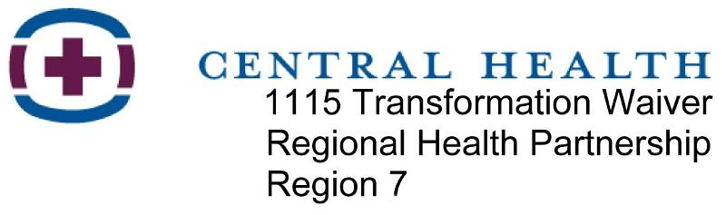
Region 7 Learning Collaborative
February 17, 2015
St. David’s Medical Center

Project-Specific Lessons Learned Template

HHSC requires that DSRIP Performing Providers submit documentation of lessons learned at Regional Learning Collaborative meetings that are relevant to their project to demonstrate participation.
Central Health developed this form to assist providers in documenting lessons learned.

Project ID:

Project Name:

Provider Name:

Identify a tool or idea about patient engagement that you learned about at the Region 7 Learning Collaborative meeting that you could use in your DSRIP project. How might you implement it?

Describe how you could implement a PDSA cycle in your DSRIP project to improve a process or outcome?

Describe your plan to implement an internal PDSA cycle or a cross-organizational collaborative PDSA cycle.

